

# National Institute of Technology Raipur

**Artificial Intelligence & Expert System**

**Term Paper**

**Decision Trees and Random Forest Algorithm**

**By**

**Kunal Sachdeva**

**Roll No. 19115045**

**(6th Semester Computer Science & Engineering 2020-21)**

**Abstract**

For classification and regression, Decision Trees (DTs) are a non-parametric supervised learning method. The goal is to learn simple decision rules from data attributes to develop a model that predicts the value of a target variable. A tree is an approximation to a piecewise constant. Random Forest is a supervised machine learning algorithm that is commonly used to solve classification and regression problems. It creates decision trees from various samples, using the majority vote for classification and the average for regression.

**Introduction**

The most powerful and widely used tool for categorization and prediction is the decision tree. A decision tree is a flowchart-like tree structure in which each internal node represents an attribute test, each branch reflects the test's conclusion, and each leaf node (terminal node) stores a class label.

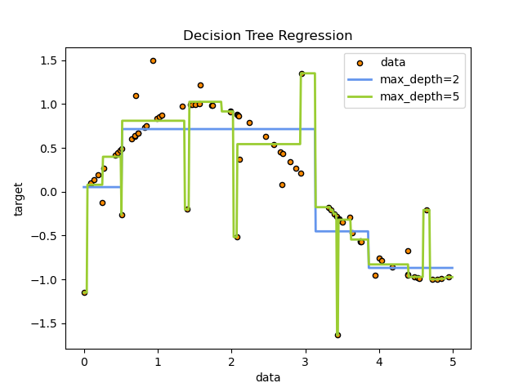In the example below, decision trees use a series of if-then-else decision rules to estimate a sine curve using data. The decision criteria become more complex as the tree grows deeper, and the model becomes more accurate.

**Advantages and Disadvantages of Decision Trees**

**Decision trees provide the following advantages:**

* They are simple to learn and interpret. It is possible to visualise trees.
* It Doesn't necessitate a lot of data preparation. Other procedures frequently necessitate data standardisation, the creation of dummy variables, and the removal of blank values. This module, however, does not handle missing values.
* The cost of using the tree (that is, predicting data) is proportional to the number of data points needed to train it.
* Able to work with both numerical and category information. For the time being, however, the scikit-learn implementation does not handle categorical variables. Other methods are often reserved for examining datasets with only one type of variable. For additional information, see algorithms.
* Capable of dealing with difficulties with many outputs.
* The model is based on a white box. If a circumstance can be observed in a model, Boolean logic can simply describe the situation. In contrast, the findings of a black box model (such as an artificial neural network) may be more difficult to decipher.
* Statistical tests can be used to validate a model. As a result, the model's dependability may be accounted for.
* Performs well even if the underlying model from which the data were created violates some of its assumptions.

**The following are some of the disadvantages of decision trees:**

* Decision-tree learners may produce overly complicated trees that may not adequately generalise data. This is referred to as overfitting. To avoid this problem, mechanisms like as pruning, establishing the minimum amount of samples required at a leaf node, and setting the maximum depth of the tree are required.
* Decision trees are inherently insecure, as slight changes in the data might result in an entirely new tree being created. The use of decision trees within an ensemble helps to solve this difficulty.
* Decision tree predictions are neither smooth or continuous, but piecewise constant approximations, as seen in the diagram above. As a result, extrapolation is difficult for them.
* Under numerous characteristics of optimality and even for simple notions, the issue of learning an optimal decision tree is known to be NP-complete. As a result, practical decision-tree learning algorithms rely on heuristic algorithms like the greedy algorithm, in which each node makes locally optimal judgments. Such algorithms can't promise that they'll give you the best decision tree in the world. This can be avoided by using an ensemble learner to train several trees, with the features and samples being randomly sampled and replaced.
* Some topics, like as XOR, parity, and multiplexer difficulties, are difficult to grasp because decision trees do not clearly describe them.
* If some classes dominate, decision tree learners build biased trees. As a result, prior to fitting using, it is recommended to balance the dataset.

**Construction of Decision Tree**

By separating the source set into subgroups based on an attribute value test, a tree can be "trained." Recursive partitioning is the process of repeating this method on each derived subset. When all of the subsets at a node have the same value of the target variable, or when splitting no longer adds value to the predictions, the recursion is complete. Because the building of a decision tree classifier does not necessitate domain expertise or parameter selection, it is well suited to exploratory knowledge discovery.

High-dimensional data can be handled via decision trees. The accuracy of the decision tree classifier is generally good. A common inductive strategy to learning classification information is decision tree induction.

**Decision Tree Representation:**

Instances are classified using decision trees by sorting them down the tree from the root to a leaf node, which provides the classification. As indicated in the above diagram, an instance is classified by starting at the root node of the tree, checking the attribute specified by this node, and then progressing along the tree branch according to the attribute value. The subtree rooted at the new node is then processed in the same way.

The decision tree in the preceding graphic categorises a given morning based on whether it is suitable for tennis play and returns the classification associated with that leaf. (In this situation, the answer is Yes or No).

The instance, for example, would be sorted down the decision tree's leftmost branch and so classed as a negative instance.

*(Outlook = Rain, Temperature = Hot, Humidity = High, Wind = Strong )*

To put it another way, a decision tree is a disjunction of conjunctions of constraints on attribute values of instances.

*(Outlook = Sunny ^ Humidity = Normal) v (Outlook = Overcast) v (Outlook = Rain ^ Wind = Weak)*

**Pruning**

Pruning a tree can improve its performance even further. It entails eliminating branches that make use of low-importance attributes. By lowering the complexity of the tree, we can improve its predictive power by reducing overfitting.

Pruning can begin either at the base or at the leaves. The most basic pruning approach starts with leaves and removes each node in that leaf with the most popular class; this change is preserved if it does not degrade accuracy. Reduced error pruning is another name for it. More advanced pruning approaches, such as cost complexity pruning, use a learning parameter (alpha) to determine whether nodes can be deleted based on the sub-size. tree's Weakest link pruning is another term for this.

**Random Forest Algorithm**

Random forests, also known as random choice forests, are an ensemble learning method for classification, regression, and other tasks that works by building a large number of decision trees during training. For classification tasks, the random forest's output is the class chosen by the majority of trees.

The mean or average prediction of the individual trees is returned for regression tasks. Random decision forests address the problem of decision trees overfitting their training set. Random forests outperform decision trees in most cases, but they are less accurate than gradient enhanced trees. Data features, on the other hand, can have an impact on their performance.

One of the most essential characteristics of the Random Forest Algorithm is that it can handle data sets with both continuous and categorical variables, as in regression and classification. For classification difficulties, it produces superior results.

**Assumptions for Random Forest**

Because the random forest combines numerous trees to forecast the dataset's class, some decision trees may correctly predict the output while others may not. However, when all of the trees are combined, the proper result is predicted. As a result, two assumptions for a better Random forest classifier are as follows:

* The dataset's feature variable should have some actual values so that the classifier can predict accurate outcomes rather than a guess.
* Each tree's predictions must have very low correlations.

The Random Forest algorithm has the following steps:

* Step 1: In Random Forest, n number of random records are selected from a data collection with k number of records.
* Step 2: For each sample, individual decision trees are built.
* Step 3: Each decision tree produces a result.
* Step 4: For classification and regression, the final output is based on Majority Voting or Averaging, respectively.

**Important Random Forest Features**

1. Diversity- When creating an individual tree, not all attributes/ variables/ features are evaluated, and each tree is unique.
2. Immune to the curse of dimensionality- The feature space is minimized because each tree does not consider all of the features.
3. Parallelization-Each tree is built from scratch using different data and properties. This means we can fully utilize the CPU to create random forests.
4. Train-Test split- In a random forest, we don't need to separate the data into train and test because the decision tree will always miss 30% of the data.
5. Stability- The result is stable because it is based on majority voting/averaging

**Difference Between Decision Tree & Random Forest**

Although a random forest is a collection of decision trees, its behaviour differs significantly.

|  |  |
| --- | --- |
| Decision trees | Random Forest |
| When decision trees are allowed to grow without supervision, they are prone to overfitting. | Because random forests are built from subsets of data and the final output is based on average or majority rating, overfitting is avoided. |
| In terms of calculation, a single decision tree is faster. | It is, on the whole, slower. |
| When a decision tree receives a data set with features as input, it will create a set of rules for prediction. | Random forest selects data at random, forms a decision tree, and averages the results. It does not rely on any formulas. |